**Java Assignment No.3**

**1.Write a program to print table of any entered number using loop.**

import java.util.Scanner;

class Table{

public static void main(String args[]) {

Scanner sc = new Scanner(System.in);

System.out.print("Enter the number : ");

int num=sc.nextInt();

for(int i=1; i <= 10; i++)

{

System.out.println(num+" * "+i+" = "+num*i);

}

}

}

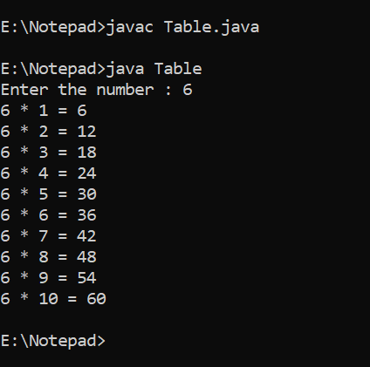

**2.Write a program to reverse a given number.**

class Reverse{

public static void main(String[] args){

int number = 123456789, reverse = 0;

//we have not mentioned the initialization part of the for loop

for( ;number != 0; number=number/10)

{

int remainder = number % 10;

reverse = reverse * 10 + remainder;

}

System.out.println("The reverse of the given number is: " + reverse);

}

}

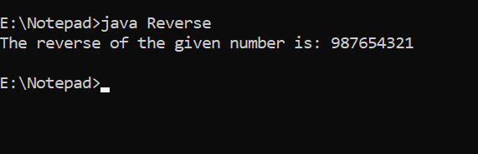

**3.Program to check whether number is prime or not**.

import java.util.Scanner;

class even {

public static void main(String[] args) {

Scanner sc = new Scanner(System.in);

System.out.print("Enter the number : ");

int num =sc.nextInt();

boolean flag = false;

for (int i = 2; i <= num / 2; ++i){

if (num % i == 0){

flag = true;

break;}

}

if (!flag)

System.out.println(num + " is a prime number.");

else

System.out.println(num + " is not a prime number.");

}

}

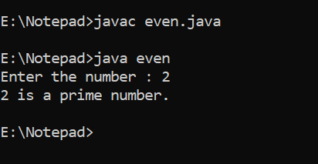

**4.Calculate series : 1 2 +2 2 +3 2 +4 2 +.........+n 2**

import java.util.Scanner;

class series{

public static void main (String args[]){

int ans=0;

Scanner sc=new Scanner(System.in);

System.out.println("enter any number");

int num=sc.nextInt();

System.out.println("series of number is ");

for(int i=1;i<=num;i++){

ans=ans+i*i;

System.out.println(" " +ans);

}

}

}

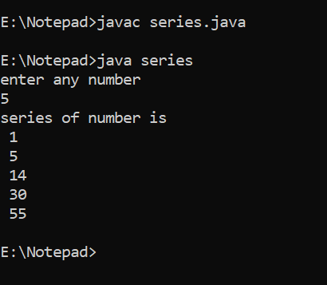

**5.Print all prime numbers between two given numbers. [ break**

continue ]

import java.util.Scanner;

class interval {

public static void main(String[] args){

Scanner sc = new Scanner(System.in);

int a, b, i, j, flag;

System.out.printf("Enter lower number : ");

a = sc.nextInt(); // Take input

System.out.printf("\nEnter upper number: ");

b = sc.nextInt(); // Take input

System.out.printf("\nPrime numbers between %d and %d are: ", a ,b);

for (i = a; i <= b; i++) {

if (i == 1 || i == 0)

continue;

flag = 1;

for (j = 2; j <= i / 2; ++j) {

if (i % j == 0) {

flag = 0;

break;

}

}

if (flag == 1)

System.out.println(i);

}

}

}

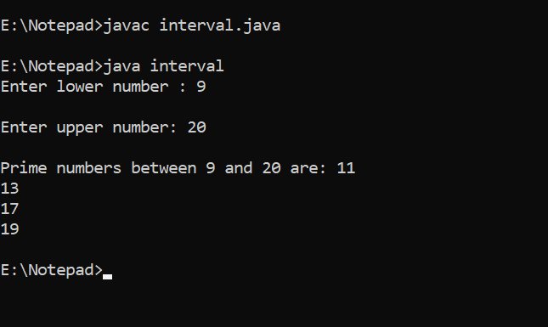

**6.Program to show sum and average of 10 element array. Accept array elements from user.**

import java.util.Scanner;

class SumAverage

{

public static void main(String[] args)

{

int n, sum = 0;

float average;

Scanner s = new Scanner(System.in);

System.out.print("Enter no. of elements you want in array:");

n = s.nextInt();

int a[] = new int[n];

System.out.println("Enter all the elements:");

for(int i = 0; i < n ; i++)

{

a[i] = s.nextInt();

sum = sum + a[i];

}

System.out.println("Sum:"+sum);

average = (float)sum / n;

System.out.println("Average:"+average);

}

}

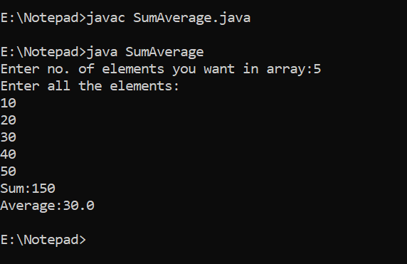

**7.Sort a ten element array in descending order.**

import java.util.Scanner;

class Descending{

public static void main(String[] args)

{

Scanner sc=new Scanner(System.in);

System.out.println("Enter the number of elements :");

int n=sc.nextInt();

Integer arr[]=new Integer[n];

System.out.println("Enter the elements of the array :");

for(int i=0;i<n;i++) {

arr[i]=sc.nextInt();

}

for (int i = 0; i < arr.length; i++) {

for (int j = i+1; j < arr.length; j++) {

if(arr[i] < arr[j]) //Compare and swap

{

int temp = arr[i];

arr[i] = arr[j];

arr[j] = temp;

}

}

}

System.out.println();

System.out.println("Elements of array sorted in descending order: ");

for (int i = 0; i < arr.length; i++)

{

System.out.print(arr[i] + " ");

}

}

}

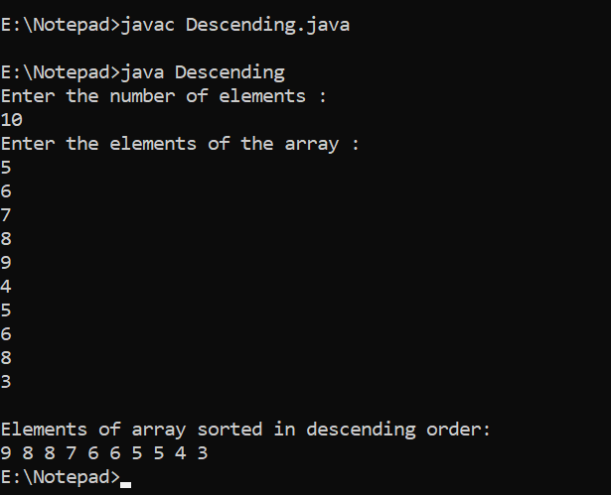

**8.Write a program to reverse the array elements.**

class reversearr {

public static void main(String[] args) {

int arr[] = new int [] {1, 2, 3, 4, 5}; //Initialize array

System.out.println("Original array: ");

for (int i = 0; i < arr.length; i++) {

System.out.print(arr[i] + " ");

}

System.out.println();

System.out.println("Array in reverse order: ");

for (int i = arr.length-1; i >= 0; i--) {

System.out.print(arr[i] + " ");

}

}

}

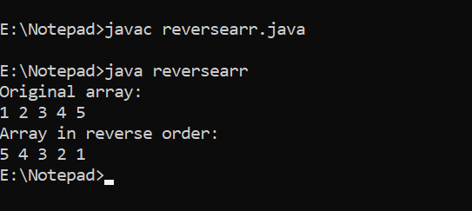

**9.Write a program to search an element in the array.**

import java.util.Scanner;

class search

{

public static void main(String args[])

{

Scanner sc = new Scanner(System.in);

int i,n,search,flag=0;

System.out.println("Enter the number of elements:") ;

n = sc.nextInt();

int[] a = new int[n];

System.out.println("Enter the elements") ;

for(i=0;i<n;i++)

{

a[i] = sc.nextInt();

}

System.out.println("Enter the element you want to be searched");

search = sc.nextInt();

for(i=0;i<n;i++)

{

if(a[i]==search)

{

System.out.println("Element "+search+" found at "+i+" position");

flag=1;

break;

}

}

if(flag==0)

{

System.out.println("Element "+search+" not found");

}

}

}

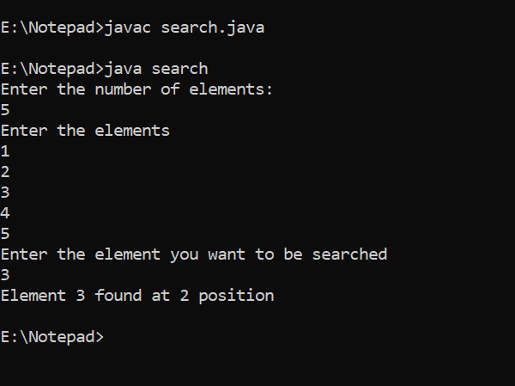

**10.Write the program to find the sum of even elements and sum of**

**odd elements present in the array of integer type.**

import java.util.Scanner;

class SumandEven

{

public static void main(String[] args)

{

int n, sumE = 0, sumO = 0;

Scanner s = new Scanner(System.in);

System.out.print("Enter the number of elements in array:");

n = s.nextInt();

int[] a = new int[n];

System.out.println("Enter the elements of the array:");

for(int i = 0; i < n; i++)

{

a[i] = s.nextInt();

}

for(int i = 0; i < n; i++)

{

if(a[i] % 2 == 0)

{

sumE = sumE + a[i];

}

else

{

sumO = sumO + a[i];

}

}

System.out.println("Sum of Even Numbers:"+sumE);

System.out.println("Sum of Odd Numbers:"+sumO);

}

}

